|  |  |
| --- | --- |
|  |  |

Yuki Security Website

Software Requirement Specification

**Project Code: YUKI SECURITY**

**Document Code: YUKI SRS v0.1**

**HCM, 22-Nov-2018**

TABLE OF CONTENTS

Introduction 3

1.1 Purpose 3

1.2 Scope 3

overal descriptions 3

1.3 Data structure 3

1.4 Actor structure 4

1.5 Use case structure 4

Functional Requirements 10

1.1 Browse 10

1.2 Login system 15

1.3 Manage Menu 17

1.4 Manage Slider 19

1.5 Manage article 23

1.6 Manage Service 27

# Introduction

## Purpose

YUKI SRS is the complete and comprehensive description of software requirement. This document describes external behaviour as well as non-functional requirements of YUKI project. It will be the basic for further analysis and design model.

## Scope

YUKI is a website that manage functions of main company website.

All the information in website are showed by these languages: Vietnamese, Japanese, English.

# overal descriptions

## Data structure

TBD in Detail Design

## Actor structure

There are 2 actors in the system: Admin and Visitor.

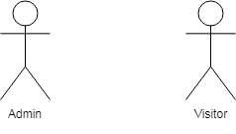Fig 1 shows actors of YUKI system separating in different roles. Each role will be granted different permissions on the system.

Fig 1: Actors in Yuki system

### Visitor role

Visitor who has not authenticated by the system with follow permissions limit, including:

* Brows: Home, Service, Outstandings, Customer, Organization, News, Contact, Outstandings Service.

### Admin role

Admin has full permissions of user and more permissions follow:

* Manage Article.
* Manage Slide show in footer and header.
* Manage Menu.
* Manage Service.
* Manage layout

## Use case structure

Fig 2 shows the basic functionalities of YUKI system in a view of use cases.

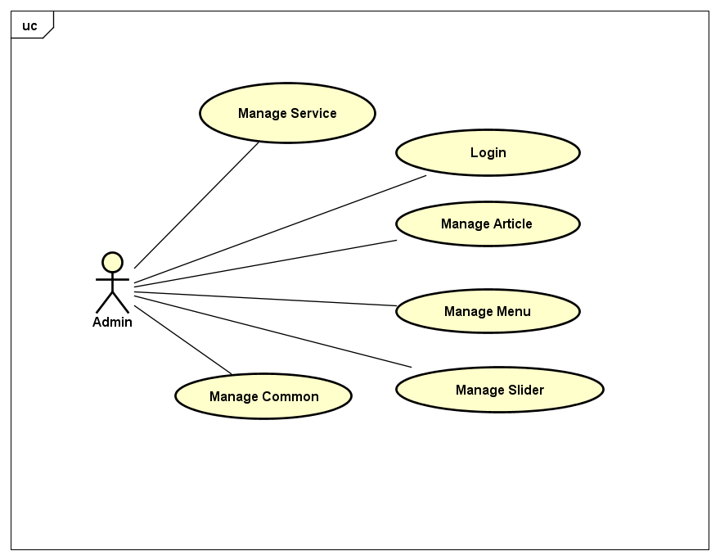

Fig 2: Use case Structure for Admin.

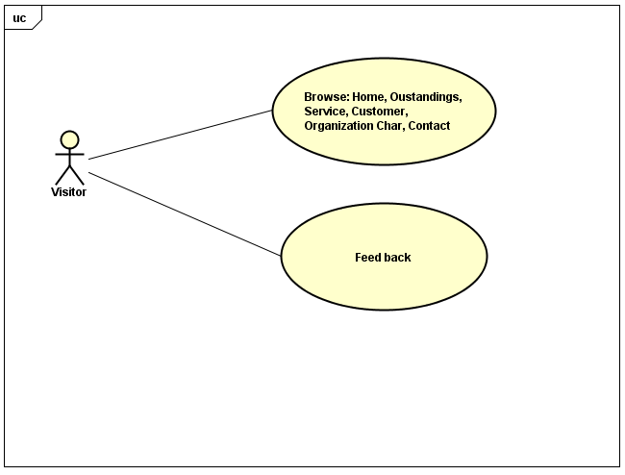

Fig 3: Use case structure for Visitor.

### Manage Article

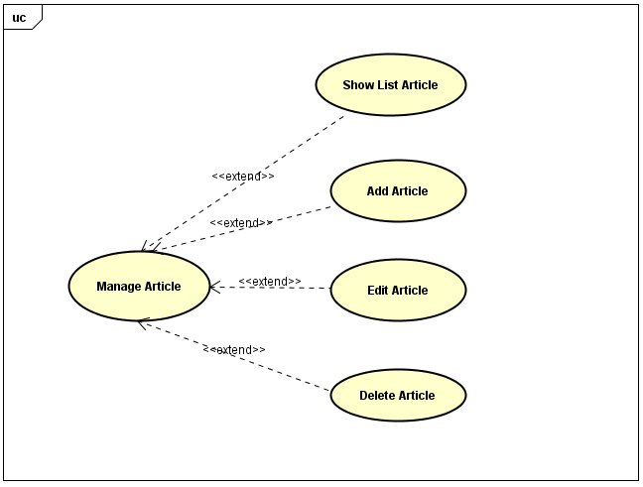

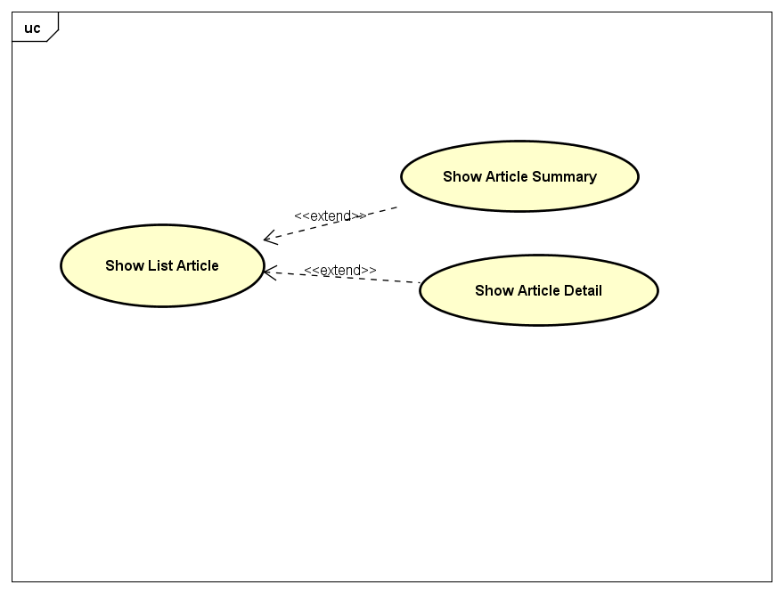

Fig 4: Use case structure manage Article.

### Manage slider

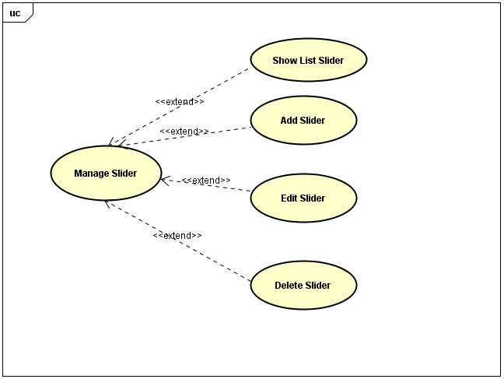

Fig 5: Use case structure manage Slider.

### Manage Menu

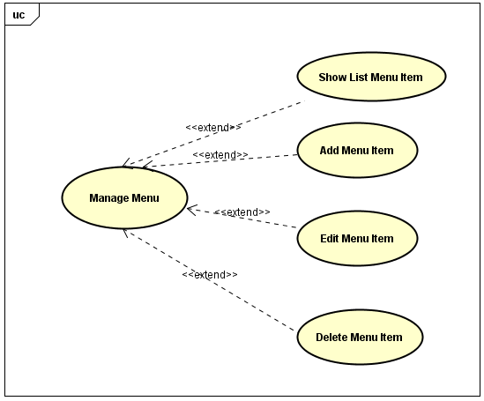

Fig 6: Use case structure manage Menu.

### Manage Service

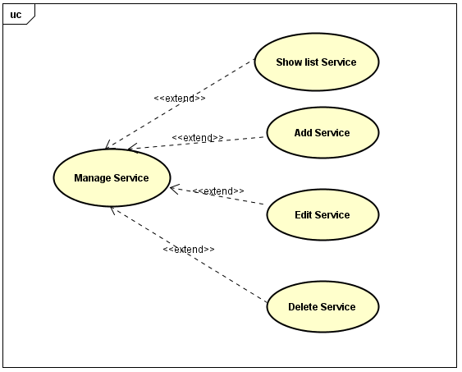

Fig 6: Use case structure manage Service.

### Manage Common

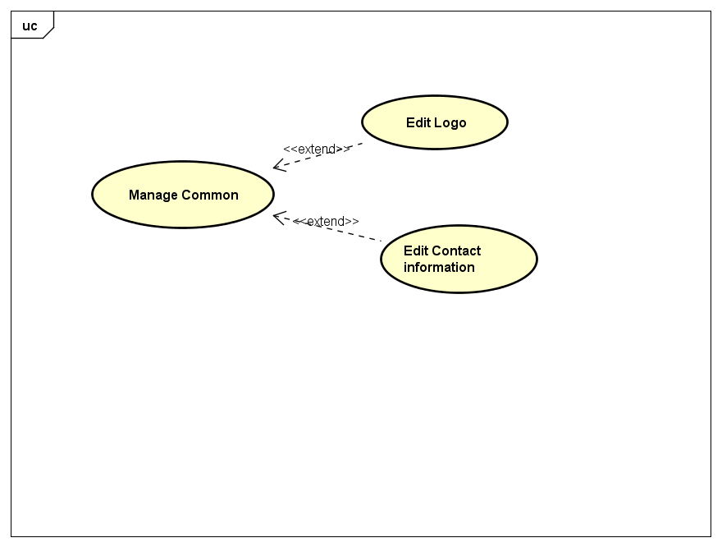

Fic 7: Use case Structure Manage Common

# Functional Requirements

This section describes the detailed functional requirements and data model of Yuki Data model.

## Browse

### Description

This use case allows visitors to browse the information follow: Home, Service, Outstandings, Customer, Organization Chart, News, Contact.

### Primary and Alternate Flow of Event

#### Browse “Home” page

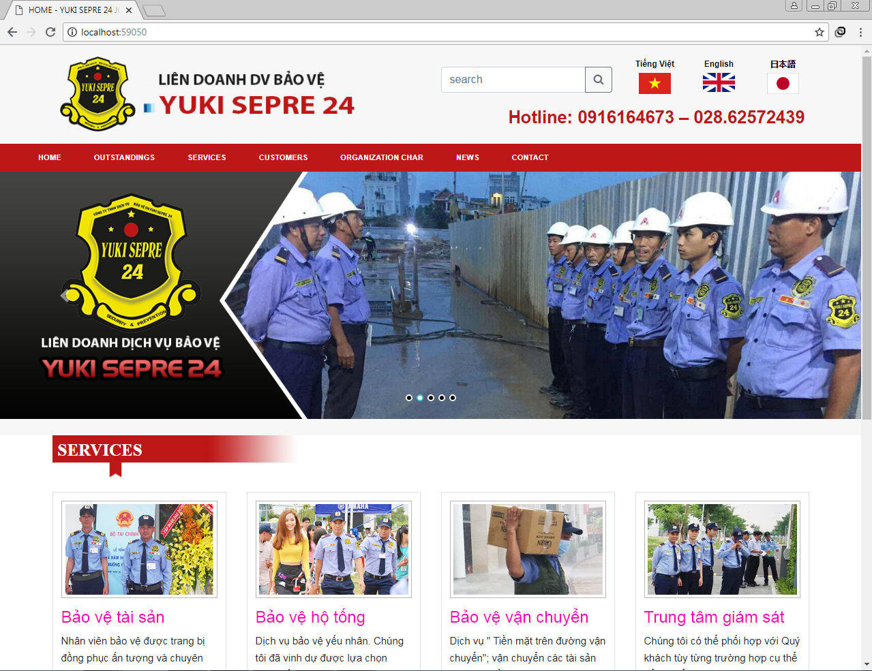

Fig 7: Screen Home Page

This screen shows services.

User choose one in tabs by clicking on a tab name, user can go to View screen, which detailed information of the subject.

#### CaptureBrowse”Outstanding” page

Fig 8: Screen Outstanding Page

This screen display content of page “outstanding” with the latest information.

#### Browse”Service” page

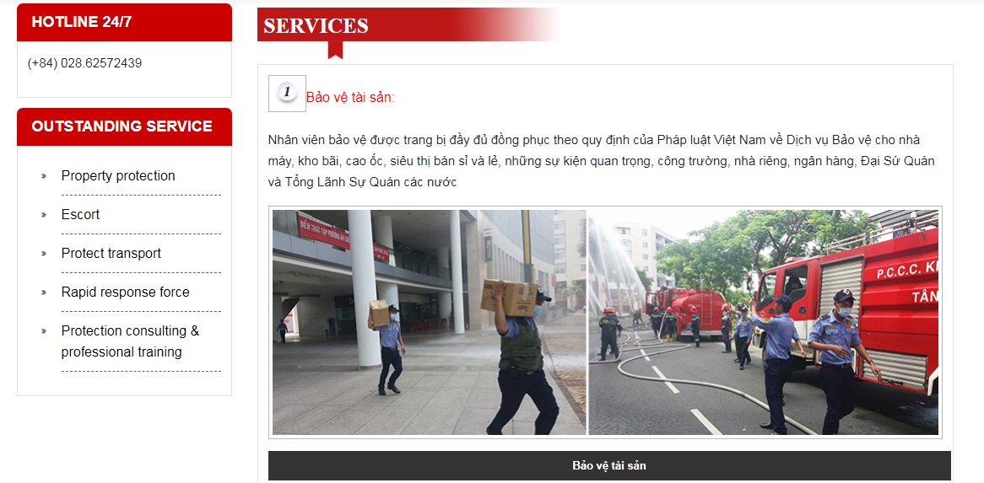

Fig 9: Screen Services Page

This screen display content of page “Service” with the latest news and the job list.

#### Browse”Customer” page

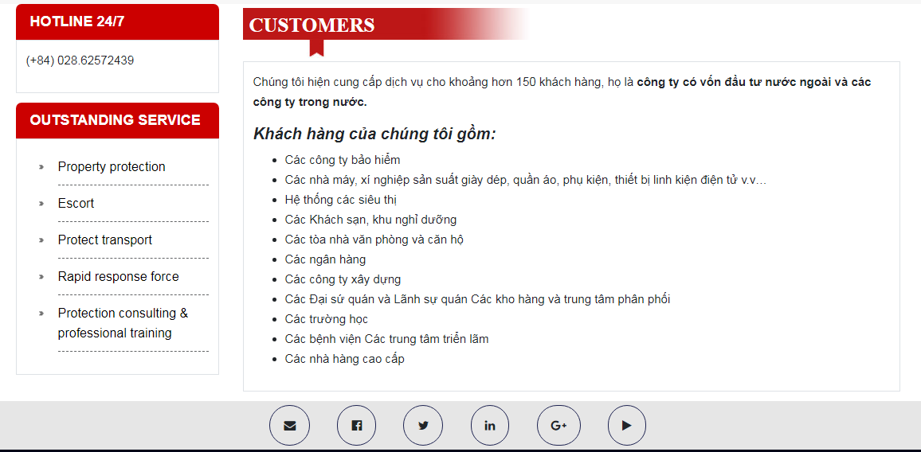

Fig 10: Screen Customer Page

This screen displays content of page”Customer” in which includes customer has worked with the company.

#### Browse “ORGANIZATION CHART” page

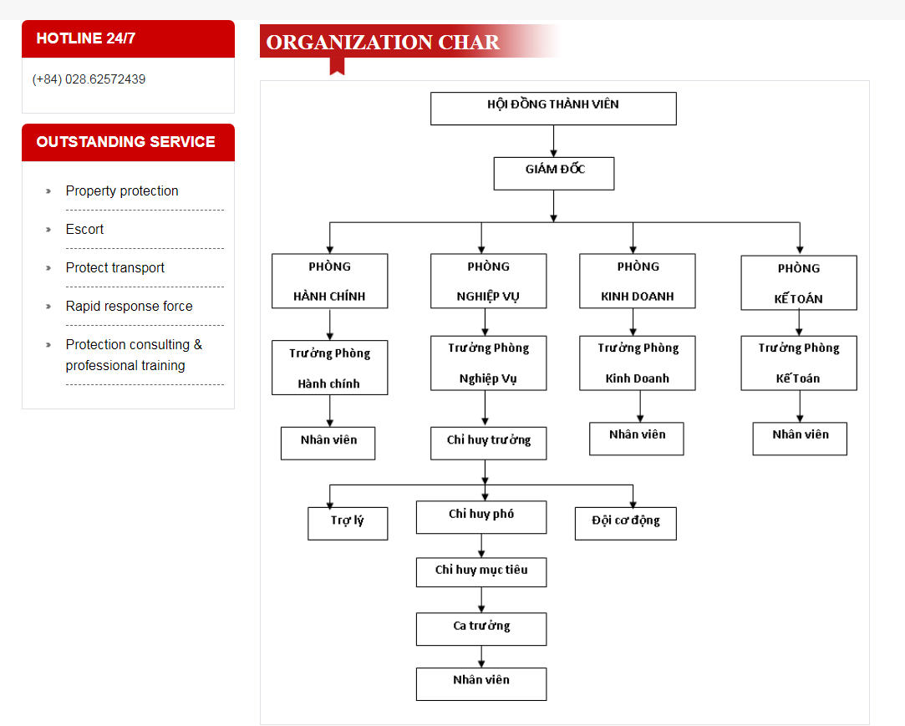

Fig 11: Screen ORGANIZATION CHART Page

This screen display page “ORGANIZATION CHART” include the organizational structure of the company.

#### Browse” Article” page

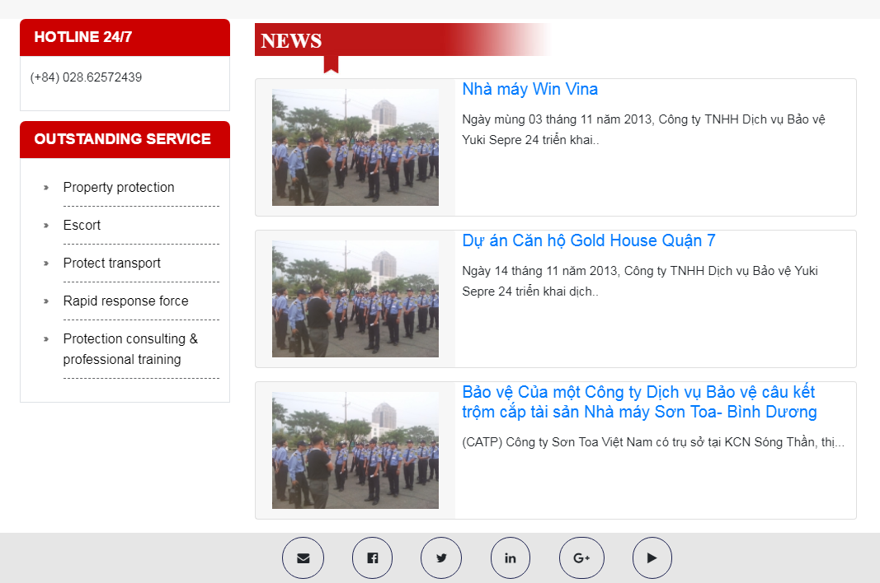

Fig 12: Screen Article Page

This screen display page “Article” with hypertext to other sections. User clicks on each tabs of this news or link other: System display content of chosen news.

#### Browse” CONTACT” page

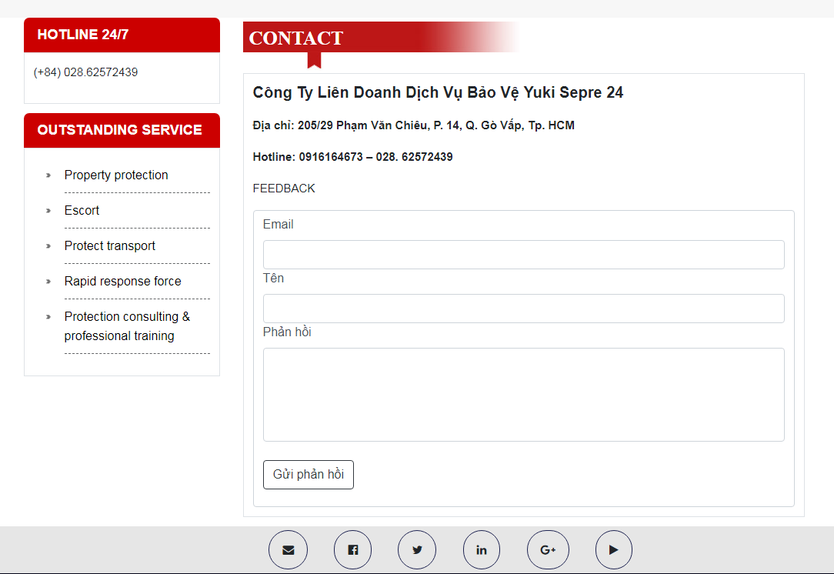

Fig 13: Screen contact Page

This screen display content of page”Contact” with hypertext to other section

* User send request, message: It seen forum.
* User composes mail, send request.

## Login system

### Description

There are 2 kinds of authentication: Admin and Visitor.

* Admin: Login to system in order to manage Article, manage Slider, and manage Menu.
* Visitor: Can view information in tab page Home, Services, Outstandings, Customer, Organization Chart, News, Contact.
* Visitor login by Email.
* The address URL for Admin’s login is different Visitor’s.

### Pre- Condition

N/A

### Primary and Alternate Flow of Event



Fig 14: Login Admin form

After User click on “Login” button:

* If username and password are correct then allow Admin logins into.
* Otherwise eject and show the login form again with error message “Username Or Password is incorrect, Please try again!!”.

## Manage Menu

### Description

This module allows admin to insert, update, delete menu information. Allow admin choose layout for menu when create or edit.

Layouts consist two template: single and multiple display type.

Have functional sort menus.

### Pre-condition

In order to use this function, user must login into system by account of admin.

### Primary and Alternate Flow of Event



Fig 15: Manage Menu form

Fig 15 Displays the current menu. If user want to create new Menu, user must click on “Create”.



Fig 16: Create new Menu form

User can change the information of Menu by click “Edit”, after changes information, user clicks “Save” button to save that changed, the system will check validations:

* Constraint:
* “Menu item name” must not be empty.

If validation fails

* Displays an error message.
* “Cancel” button to close form and cancel change action.

Fig 17: Update Menu form

- Admin can delete menu by selecting that menu and click on “Yes” button.

- When user click “delete” button must check reference to tables other:  
 + If exist in entities other, show message “This menu reference to tables other, you cannot delete it?”

+ Else show message “Are you sure to delete this menu item?”, then delete.

 + If user clicks “No”, then close form delete.

Fig 18: Delete Menu form.

## Manage Slider

### Description

This module allows admin manage slide.

When visitor click image in slider -> full-size image

### Pre-condition

In order to use this function, user must login successful in to system with role admin.

### Primary and Alternate Flow of Event

The list slide screen is displayed follow:



Fig 19: List slide form.

This screen show list slide show in footer and header. When user click "Create New", the screen create dialog slide will be displayed.



Fig 20: Add new Slide

After admin fill full information, click “Save” button to save information slide into database, after that list slide screen is displayed again.

If user want to update the slide, click “Edit” from list slide screen. After form dialog is displayed.



Fig 21: Edit Slide form

- When user click “delete” button must check reference to tables other:  
 + If exist in entities other, show message “This menu reference to tables other, you cannot delete it?”

+ Else show message “Are you sure to delete this menu item?”, then delete.

+ If user clicks “No”, then close form delete.



Fig 22: Delete Slide form

## Manage article

### Description

This section allows user manage article information as: Create new article, Update article and Delete article.

Admin can choose display article detail or summary

Admin can drag and drop article.

### Pre-condition

In order to use this function, user must login system by account of admin.

### Primary and Alternate Flow of Event



Fig 23: Manage article form

There are 3 functions to manage article posting:

* Create new article
* Edit article
* Delete article

### Add new article

The screen is displayed follow.



Fig 24: Add new article form

* Input “Title” of article information (mandatory)
* Choose image of article information (mandatory)
* Choose language of article information (mandatory)
* Input “Content” of article information (mandatory)
* Click on “Save” button to save this article to database. After posting successful, this screen will go back manage article page.
* Content must is Rich Editor.

### Edit article

The screen is displayed follow:



Fig 25: Edit article form.

This function allows you update previous article information. After changed, if you want to update this one, click on "Save" button to save it, else click on "Cancel" button. After then clicks on it "Save" or "Cancel" button, the screen will go back manage article page.

### Delete article

The screen is displayed follow.

- When user click “delete” button must check reference to tables other:  
 + If exist in entities other, show message “This menu reference to tables other, you cannot delete it?”

+ Else show message “Are you sure to delete this menu item?”, then delete.

+ If user clicks “No”, then close form delete.



Fig 26: Delete article form.

## Manage Service

### Description

This module allows admin to insert, update service information.

### Pre-condition

In order to use this function, user must login into system by account of admin.

### Primary and Alternate Flow of Event

The list slide screen is displayed follow:



Fig 27: Manage service page

There are 3 functions to manage service:

* Add new service.
* Edit service.
* Delete service.

### Add new service

The screen is displayed follow.



Fig 28: Add new service form

* Input “Service Name” of service information , must not empty (mandatory)
* Click “Choose File” to add image input for “Ảnh” of service information, must not empty (mandatory)
* Input “Language” of service information by select from 3 language: English, Japanese, Vietnamese must not empty (mandatory)
* Input “Content” of service information, must not empty (mandatory)
* Click on “Save” button to post this service. After posting successful, this screen will close, it is go back manage service posting page. (See the content of “Manage service” page.

### Edit service

The screen is displayed follow:



Fig 29: Edit service.

This function allows you update previous service information. After changed, if you want to update this one, click on "Save" button to save it, else click on "Đóng" button. After then clicks on it "Save" or "Cancel" button, the screen will go back Manage service page.

### Delete service

The screen is displayed follow.



Fig 30: Delete service

- When user click “delete” button must check reference to tables other:  
 + If exist in entities other, show message “This menu reference to tables other, you cannot delete it?”

+ Else show message “Are you sure to delete this menu item?”, then delete.

+ If user clicks “No”, then close form delete.

## Manage Common

### Description

Admin edit contact information such as number phone, address, emmail

### Pre-condition

In order to use this function, user must login into system by account of admin.

### Primary and Alternate Flow of Event

Edit Logo

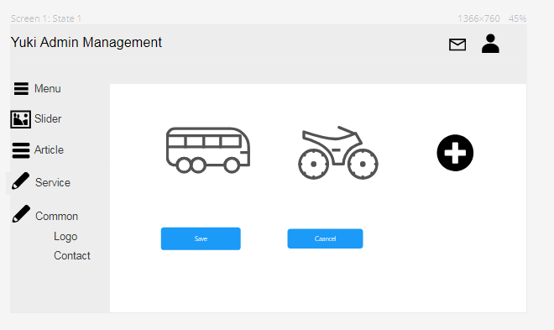

Admin select logo exist and save to change Logo or press button “+” to open tool box to choose image from computer then click save button to change logo

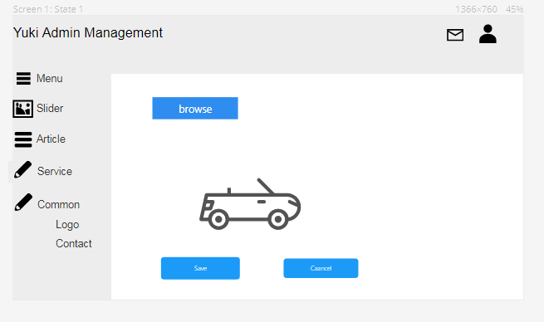

Edit Contact Information

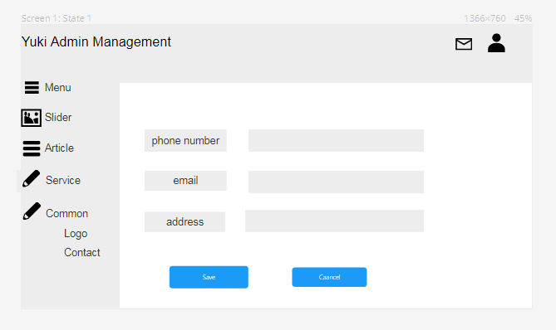

Admin edit contact information and click save button to change contact information